**Department of Electronics & Communication Engineering**

(Faculty of Technology, Dharmsinh Desai University, Nadiad)

**Academic Year: 2022 - 2023**

**TUTORIAL – 5**

**Subject:***(ESC101) BASIC ELECTRICAL ENGINEERING*

**Class :**  *B. Tech. Sem.I (EC/CE/IT)*

**Topics:** *Superposition theorem, representation of sinusoidal waveforms, peak and rms values*

1. Verify the superposition theorem for the following circuit.

Take, R1 = R4 = 1 kΩ, R3= R6 = 3.3 kΩ, R2 = R5 = 2.2kΩ, V1 = 12 V,and V2 = 5V

1. Verify the superposition theorem for the following circuit.

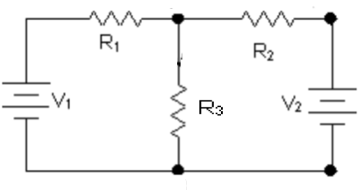

Take, R1 = R2 = 10kΩ, R3 = 2.2kΩ,V1 = 10 V and V2 = 20 V.

1. Find the Form factor and Peak factor for the waveform given below.



1. An alternating voltage is defined by v = 220 sin 377 t. It is applied to a circuit having a resistance of 22 Ω. Determine (a) the RMS value (b) the frequency (c) the power loss.
2. An alternating current varying sinusoidally with a frequency of 50 Hz has anRMS value of 20 A. Write down the equation for the instantaneous value and find this value(a) 0.0025 second (b) 0.0125 second after passing through a positive maximum value. At what time,measured from a positive maximum value, will the instantaneous current be 14.14 A?

# Prof. Narendra Chauhan*(*[*nvc.ec@ddu.ac.in*](mailto:nvc.ec@ddu.ac.in)*)*

# **Prof. J. M. Shah** ([*jmshah.ec@ddu.ac.in*](mailto:jmshah.ec@ddu.ac.in))